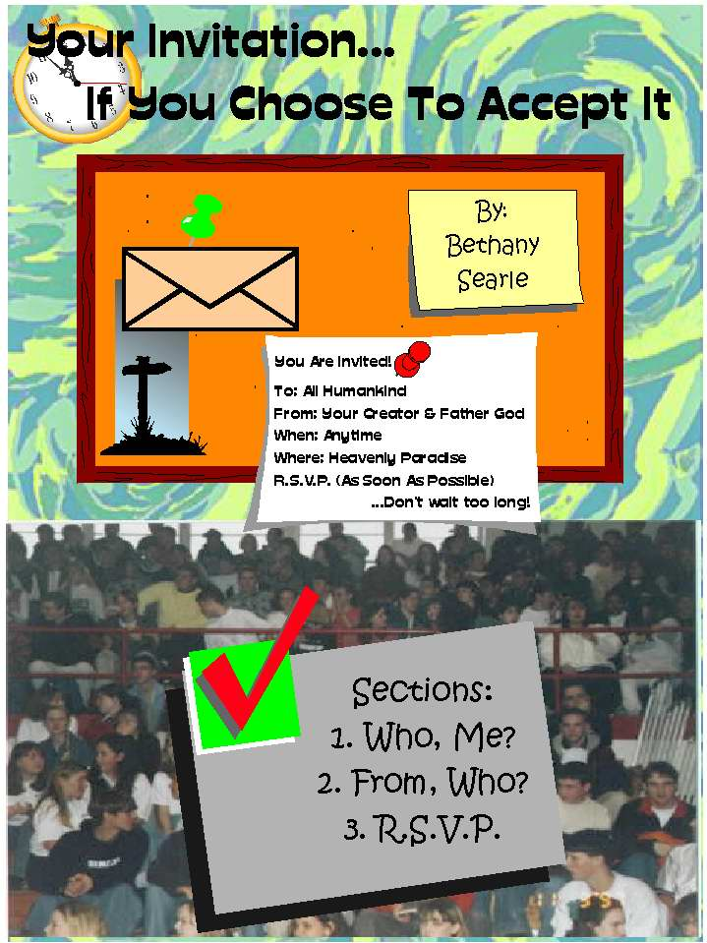



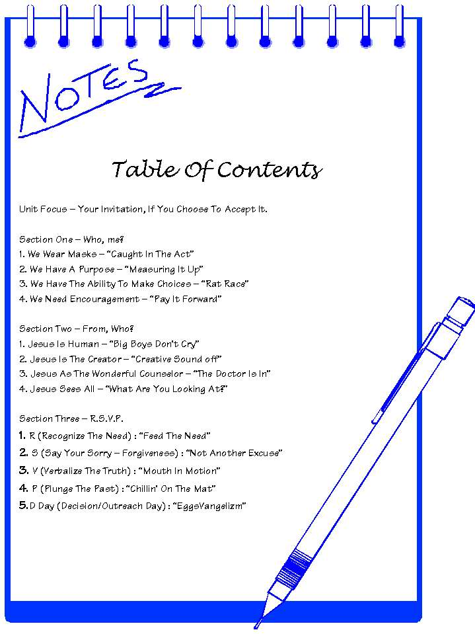



Lesson #1
Title: “Caught In The Act”
Topic: We Wear Masks
Unit Purpose: Discovering “who” we are as humans
Aim: The students will be able to commit to taking off part of his or her mask for at least one day this week.

Materials For The Lesson:
-Aluminum foil
- Tape

Room Set-Up
There are no special criteria for the room appearance. There should be an elevated platform for the speaker, a blank wall or table and enough room for the entire class to move around.

Usage Record
Date: Location: Age Group/Occasion

HOOK (15 minutes)
Each member of the class (sponsors as well) receives a sheet of aluminum foil. Ask (and exemplify) for each person to press the piece of foil against their face and gently lift the foil off. Obviously, a mask has been created. Give a moment for each student to compare theirs with others in the room (a typical reaction). Ask for everyone to place their “mask” gently on the floor, for you wouldn’t want to harm this piece of art that they have created. See if the students can identify whom’s mask goes with the faces in the room. Most likely, this task will come very easy for the group.
Then tell each student to bring their mask to the front of the room and place them with tape on a board or table so that all can see the work. Leave the masks on display and begin the lesson (Book).

BOOK (15 – 20 minutes)
Begin with a skit using the masks on stage (this can be acted out by students or a drama team involved with the group.
The drama begins on a Sunday morning and all goes well. The minister gives a short speech and the group prays. The next scene involves just the kids that were present in the Sunday class and a few others. The kids that were in church are wearing masks as they walk through their hall at school. They “fit in” well with those who are not wearing masks until they are invited to a party with alcohol present. They accept and the scene ends. The next few scenes can involve anything that puts a Christian in a tempting situation where the Christian desires to “fit in” by doing the wrong action (examples, cheating on a test, lying to their parents, porn on the internet, making fun of someone at school, etc.). After each person with a mask is tempted, the return to church with the masks on. They lie about how well their weeks went. Someone labeled “Jesus” walks by the people wearing the masks (the rest of the people in the scene freeze). “Jesus walks by calling for His followers. The people with their masks on try to get their masks off, but pretend they are stuck to their face. They call out to Jesus saying, “Wait! We are your followers.” In response Jesus comes to their side, inspects each person and says to the entire group, “I’m sorry, but I don’t recognize you.” The drama ends.
The leader of the group approaches and mentions that we call wear masks. We have different personalities in and out of school. The question is, “Who are you?” Are you wearing a mask? Are you hiding your faith so that your “friends” don’t see the real you? If Jesus could reach down and grab you by the collar right now, would he recognize you as a follower of Him?
The verses to be shared are as follows:
(Rev 3:15-16 NIV) “I know your deeds, that you are neither cold nor hot. I wish you were either one or the other! So, because you are lukewarm--neither hot nor cold--I am about to spit you out of my mouth.”
The verse in explanation mentions that when we wear masks, we can be seen as lukewarm – we are not on fire for God, but we aren’t cold either. We may go to church, say a prayer or two and maybe even do a daily devotion. But what happened to standing up to peer pressure and following God outside of the church walls? God said that people who act two different lifestyles would be spit out of His mouth (If anyone can chuck a spit wad, it would be the creator of the universe). Would you want to be in God’s mouth or would you like to serve as God’s mouth? It’s your choice but you have to loose the mask first.

LOOK: (10 - 15 minutes)
Ask the class to go back and get their masks. Then ask each person to crumble up his or her masks; acting like you will be coming around with the trashcan, but stall. Take your crumpled up mask and place it back over your face (you may have to press down harder than before). Take it off of your face and show the class the new mask. Lay the mask right by your face. God created humans to be without masks, because he does not want to see us look like this (raising up the mask). God does not see a smooth, round and shiny mask when he sees you…instead; He sees a crumpled up, piece of mess. Aluminum foil can make a great spit wad.

When does God see you wearing the mask? Why does he see you wearing a mask at all? Form groups and come up with some personal experiences or examples of why we wear masks. The list cannot contain anything in the skit. Think about why we wear masks at church. (After five minutes, go over the questions with the group and get their responses.

TOOK: (10-15 minutes)
Give each member a piece of aluminum foil and tell him or her to roll it into a small ball. They can stick it in their purse, pocket, wallet or best in their shoe for an entire day or week. Ask each person to keep a record of how his or her week went as far as not wearing a mask. Furthermore, remind them that the small aluminum ball can work well as a spit wad (not to be used in class).

Lesson #2
Title: “Measuring It Up”
Topic: We Have A Purpose
Unit Purpose: Discovering “who” we are as humans
Aim: At the end of this lesson, the student should be able to identify a “ruler” in their life and aim to put down one area of measure in their life.

Materials For The Lesson:
- Long sheets of white construction paper or measuring string
- Props for the skit (extra)
- Ruler illustration
- Cross

Room Set-Up
Follow the set-up used for the “Caught In The Act” lesson.

Usage Record
Date: Location: Age Group/Occasion

HOOK (15 minutes)
Silent drama – One main character is always trying to be like everyone else on stage, regardless the situation. The first scene has a few people sitting in a Bible study group. The main character approaches and is pushed away by everyone in the group, until the leader pulls him aside. The leader has a measuring tape in his pocket and measures the main character (his/ her tallness and waist size, etc.). Then the leader measures one of the group members, following the exact same pattern of measuring. Shaking their head, the leader shrugs to the main character and puts the measuring tape around the main character’s neck. The next scene can be of an awards ceremony. The main character does not receive an award and he is measured and another measuring tape is added around his or her neck. Another setting could involve a family where the main character fights with a sibling and receives another measuring tape around his or her neck by the parents (applauding the “well behaved” other sibling). The final scene is with the main character alone on stage in tears, feeling outweighed by the measuring devices around his or her neck. A cross is eventually recognized in the background. Jesus is eventually seen being brought up into the stage by an angry mob. As Jesus is nailed to the cross, the main character measures the boards. As Jesus lies on the cross, the main character puts his measuring tape around Jesus’ neck. Jesus is raised up on the cross and the character begins to weep, bringing him or her down to their knees. Jesus makes eye contact with the character and the character brings out one last measuring tape out of his or her own pocket and places it around the cross. The main character can be heard walking off the stage as Jesus’ head bows down symbolizing Christ’s death.

BOOK (15 – 20 minutes)
(Mat 7:1-5 NIV) "Do not judge, or you too will be judged. For in the same way you judge others, you will be judged, and with the measure you use, it will be measured to you.
Why do you look at the speck of sawdust in your brother's eye and pay no attention to the plank in your own eye? How can you say to your brother, 'Let me take the speck out of your eye,' when all the time there is a plank in your own eye? You hypocrite, first take the plank out of your own eye, and then you will see clearly to remove the speck from your brother's eye.”
In order to explain the text in today’s terms, another “live/realistic drama” is used. Get two guys who are usually outspoken to come barging in the door. One is yelling at the other to leave him alone. The other has a massive wad of toilet paper stuck in his shoe and is yelling that his friend has gum on the bottom of his shoe. The friend lifts up his shoe and the guy points out a spec (un-noticeable to the audience) of “gum” on his friend’s shoe. The teacher intervenes and asks the class who should be telling whom what to do. The class discusses the lively action and the usual result is that the guy with the small piece of “gum” wins the argument. However, the question is then asked, “Should we point fingers at all? What ever happened to the phrase – people in glass houses shouldn’t throw stones?” Mention the fact that the boy, even with a spec of gum on his shoe should remove it before helping the guy with toilet paper (more noticeable). We have to get rid of our own measuring tape before trying to help others get rid of theirs.

LOOK: (5 - 10 minutes)
Everyone has something that they struggle to measure up against. Parents are so demanding of their children, trying to get them to be like their other siblings or even like themselves. School is often a place where everyone wants to fit in, no matter what the cost (drinking, drugs and even sex). Church even has its “popular clicks” where if you don’t act the “right way” then you are not accepted. Provide an example of each to the class, while passing out white construction paper (similar to a measuring rope). After all the paper is passed out, ask the question, “What are you measuring up to?”


TOOK: (10-15 minutes)
Ask each person to label their paper with an area that they will try to put down their measuring stick. Ask each person to then bring his or her papers forward and cut a piece of the “measuring tape” off of each paper. Give the small piece back to the student and lay the bigger piece under the cross. Close the class by praying over the pieces of measuring tape. As the students prepare to leave, mention that they will have a chance this week to completely drop their rulers, for that’s why you gave them a small piece of paper (for a reminder). Action is obedience and in order to truly drop a measuring stick, you must act without it in your life.

Lesson #3
Title: Rat Race
Topic: We Have The Ability To Make Choices
Unit Purpose: Discovering “who” we are as humans
Aim: At the end of this lesson, each student should be able to identify where his or her choices have led him or her in their walk with Christ and decide where they want to be in the future.

Materials For The Lesson:
- Rope Course
- Audio Adrenaline song, “Walk On Water”
- Device to play music
- Safety equipment for the course
- First Aid kit
- Envelopes
- Paper
- Pencils
- (Optional) Video and still camera
- Prizes

Room Set-Up
This session is to be planned for a few hours at a rope course. The weather needs to be decent and therefore, the entire lesson can be done outdoors. If the weather is bad, reschedule the lesson for another day and continue with the outline.

Usage Record
Date: Location: Age Group/Occasion

HOOK (15 minutes)
Depending on the size of the group, divide the students into smaller, competing teams. Do not tell the students where the event will be held, but notify the parents in advance. Inform the students that street clothes attire will be best for the activity. Tell each team that they will have an hour to get through the “event” that awaits them. Have a prize (ice cream sundaes, money, something donated lying at the end). When the teams arrive, guides are present to move them from various settings of the rope course. To avoid back up, assign each team a different obstacle (s) to accomplish. Once a team is completed, they remain at the end. It may be wise to videotape the action and teamwork.

BOOK (15 – 20 minutes)
After all the teams eventually cross the finish line, show each of the groups the various obstacles that the groups had to overcome. Allow a few minutes for the group to share testimonies and experiences. At the end of the sharing, ask the question, “Why are we here?” Answer, which you may have to state yourself, “You chose to come and participate, it was your choice.”
With the students back in their small groups, ask the students to read the passage Matthew 14:22-33. Ask each group to define who made the choice of this story and why the choice was made. While the groups are working, pass out paper and markers to one group (ask each member to draw a modern example of the story), tell another group to write and perform a rap about the passage while providing them with a pen and paper, and another group can do a skit with the theme, “Good Idea, Bad Idea.” After the students work for about ten minutes, read the passage aloud and answer the question that was presented earlier by asking the students again. There is no “right answer” because students see the verses in a wide variety of angles. Let each group present their project (you may want to videotape these for later uses). After the last group is completed, go into the “Look.”

LOOK: (5 minutes)
Take the story from Peter’s perspective. Paint a picture describing the storm (or how it might have been) and imagine seeing your own reflection on a mounting wave as you step out into the crashing sea. Peter made a choice, to come to the “ghost” which might have caused his own death.
Make the point that each person present made some form of a choice to get where they did today. You may want to reflect on the trials involving the rope course. However, make one last question to the group, “What choices are you making in your own life to come closer to Christ?” Explain the waves (drugs, alcohol, peer pressure, parents, etc) that surround everyone. The awesome point is this: By gaining the choice to come to Christ, against all odds, we can beat all odds (walk on water).
Ask the group just to think of what they need to do to step out of the boat, or reach out for Jesus hand (if the waves have already consumed them). Ask the group to identify where they are and where they want to be a month from now. Play the Audio Adrenaline song during this time.

TOOK: (10-15 minutes)
Pass out paper and pencils to the entire group and ask each person to literally, write a letter to themselves. Tell them to include where they want to be a month from now and to write down the scripture reference that was shared. After they complete the letter, tell them to address the envelope to themselves and slip the letter inside, licking it shut (promise the group that you will not read the letters). A month later you can send the letters back to the group, around mid-week along with the poem and possibly even a few pictures that you took of the group at the rope course.
After collecting the envelopes, share the poem below and end the class period by praying over the letters. Note – write a thank you note to the owners of the rope course and mail it that same week.

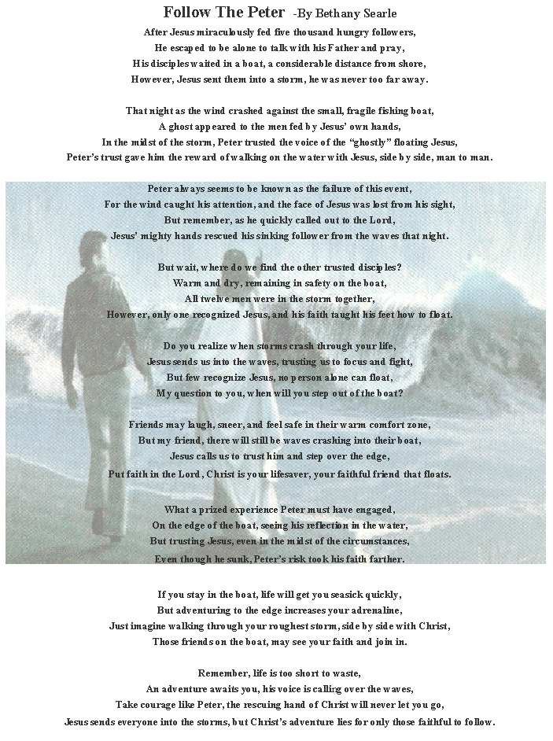

Lesson #4
Title: “Pay It Forward”
Topic: We need encouragement and we can be encouragers
Unit Purpose: Discovering “who” we are as humans
Aim: At the end of the lesson, each student to “pay it forward” to three other people in the next week.

Materials For The Lesson:
- “Pay It Forward” video/DVD
- Proper video or DVD player
- Note cards
- Envelopes and stamps (optional)
- Pens

Room Set-Up
The room needs to have a theatre and a relaxing atmosphere. This can be done by having two different settings or by just combining round tables and chairs around a big screen projector. It is crucial that each person is able to hear and see the movie when played. Music can be playing when students enter along with part of the “Pay It Forward” documentary (if on DVD). Snacks and coffee are optional, but does impact the atmosphere.

Usage Record
Date: Location: Age Group/Occasion

HOOK (15 minutes)
Show two parts of the “Pay It Forward” movie. The first clip has the boy at the chalkboard drawing out and explaining his ideas. After the kids respond the clip stops. The second clip is at the very end of the movie when the candles and flowers are being laid at the doorstep of the home.
Explain to the group that the final scene is filled with all the people that have been touched by the “Pay It Forward” phenomenon. For a group discussion, ask the question, “What does the Bible say about this concept?”

BOOK (15 – 20 minutes)
The following verses should be read out loud or discussed within the groups.
(Deu 23:19 NIV) Do not charge your brother interest, whether on money or food or anything else that may earn interest.
(Deu 23:21 NIV) If you make a vow to the LORD your God, do not be slow to pay it, for the LORD your God will certainly demand it of you and you will be guilty of sin.
Make the mention that the book of Deuteronomy was written by Moses, the servant of God chosen to lead the people out of Egypt. Also, the book is filled with commands given to the people to obey and follow.
“19-20 When the nation was first established, the Israelite economy was by no means mercantile; loans were made primarily to help persons too poor to support themselves. Such assistance was to be given without interest. But since merchants from other nations might come for business reasons to Israel or might make loans on interest to Israelites, foreigners could be charged interest. This rule alleviated the plight of the poor and made it more possible for them to work themselves out of their low estate. Interest is also regulated in Ex 22:25 and Lev 25:36-37. The Lord's blessing on the labors of God’s people in the land was contingent on following this directive. “
Not only were the Israelites prompted not to charge their own brothers, they were told not to charge anyone. Therefore, they did an act of helpfulness to a person to glorify God.
Prompt the question, “When was the last time you did something for a friend or enemy and expected nothing in return?” We all want to get something back, but we forget that just encouraging others through Christ gives us more than enough pay back, for it is from God.

LOOK: (10 minutes)
Before the segment of the movie where Trevor is drawing his idea on the board, his mom meets the guy Trevor has helped the previous night. To avoid too graphic scenes (the scars on the man’s arm) the tape can be started right after he says, “I can lick it.” The tape should be stopped when the chalkboard scene resumes.
The question needs to be asked, “When have you, in your lifetime done something that has truly impacted the life of another and expected no return?” No loud answers are needed, but just give a minute for the class to think about that question. Then ask, “Isn’t it about time that we learn to help out people in our church, community and world?” Mention the fact that everyone has gone through a hard time and everyone needs someone to lean on in those times. In the movie, Trevor literally rescues a man off the streets and gives him a second chance at life. Though our ideas may not be that dramatic, a small note mentioning that a prayer has been said for a person, a favor done anonymously or just an encouragement letter can literally change a person’s life. Christ calls us to encourage one another “(Heb 3:13 NIV) “But encourage one another daily, as long as it is called Today, so that none of you may be hardened by sin's deceitfulness.” Note that “today” means the current day (not tomorrow or a few weeks from this day).

TOOK: (10-15 minutes)
Pass out the note cards to each member of the class. Ask them to write a note to three people (it can be anyone) and at least one of the three needs to be out of the church walls. If envelopes and stamps are provided, tell the kids to either mail their note off this week, present it to the person, or they can even send it by e-mail. Remind each person to ask the recipient to send an encouragement letter to three more people and not to return the favor. Verses mentioned in this lesson can also be added to the messages. For an even deeper project, encourage the group not to sign the encouragement note and just observe the change in the person’s behavior.
Showing the clip of the video that was shot with Trevor right before he died in the movie can best end the class. At the end of the clip, tell each person present that there will be a time next week set aside for stories of how their “Pay It Forward” plan worked.




Lesson #5
Title: Big Boys Don’t Cry
Topic: Jesus truly cares and has felt everything we experience.
Unit Purpose: Discovering “who” really is Jesus
Aim: At the end of the lesson, each student should be able to turn his or her feelings to God for healing by writing out a postcard at the end of class.

Materials For The Lesson:
- “The Green Mile” Video/DVD
- “Jesus” or another adaptation of the death of Jesus on the cross
- Applicable player for the media
- Jesus Wept postcards (picture included at the end of this lesson plan)
- Envelopes
- Pens

Room Set-Up
Chairs need to be formed in a casual setting but also in a way that all attendees can see the television in which the media is to be played. The room could be designed in a café setting with another section for the theatre use.

Usage Record
Date: Location: Age Group/Occasion

HOOK (15 minutes)
Depending on which movies are chosen, segments are preset and ready to go. There are several movies available currently which tough guys, usually seen as the hero, initially in tears due to a situation. The movie can be run two different ways.
- Several clips of famous movie heroes in their starring roles can be shown back to back (it would be a great idea to record all of the clips on a single video, if the hardware is available). At the end of the clips, a clip of Jesus on the cross is shown, followed by black. To make this even more dramatic, the last segment, which focuses on current stars, can put the actor in a humorous role. Therefore, when the cross scene is shown, emotions go from one extreme to the complete opposite.
- The “Green Mile” movie can be cued to where the man on death row is in tears, followed by a clip of Jesus on the cross. After the two clips the following question is prompted, “Why says real men can’t cry?”

BOOK (15 – 20 minutes)
“A boy was trying to earn a few gold stars in his Sunday school class for memorizing various of verses throughout the Bible. Several children had already recited the Lord’s Prayer and even the Sermon on the Mount. However, when it was his turn to recite a verse, he could only say, “Jesus wept.” The teacher put one star beside his name for his accomplishment. He knew that all of the others had received several stars for their memorization, and he decided that one star just wouldn’t do. So the boy concluded his verse by adding, “And he wept and he wept, and he wept a whole lot more!” (Sermon story – Southland Christian Church)
Just like tossing up a coin, this story has two sides. The first being quite humorous, but the second having a relevant purpose to a Christian’s life. The verse John 11:35 is uniquely quoted in the latter story. Many people don’t realize how special those two words are to the entire Kingdom of God.
John 11:35 means that our Savior of the world, who could overcome all odds, shed tears over a human in which he loved. It has been quoted that “Jesus wept. The shortest verse in the Bible and one of the most touching.” Why? What does that really mean to you? (Small group discussion).

LOOK: (5 minutes)
Why are we so afraid to reveal how we feel to our creator? The one counselor who walked in our shoes on this earth and that has felt every pain that comes crashing in your life, wept. Why can’t we? (Entire group can give feedback at this point)

Each human being is going to feel pain at one time or another. We break up with our boyfriend or girlfriend, we fight with each other, we disagree with our family, we receive bad grades at one point or another, we literally just have flat out bad days. What we need to realize is that Jesus is right there with us, crying by our side. Newsflash, when the world seems to be against you, Christ is right by your side! He cares enough to shed a tear on your behalf, why can’t we just give out true tears to him? It’s time to realize that we all hurt, but there is only one who will never leave your side and that knows your heart. Big boys don’t cry, only true followers of Christ weep and show that they struggle. However, once we recognize that we are not perfect, God can take over and show us where to go. What are you hurting about? What is Jesus crying about in your life?

TOOK: (10-15 minutes)
Pass out the “Jesus Wept” postcards to everyone in the class (including sponsors). Ask each person to draw or write something down on the back of the paper that deals with what or where they are spiritually hurting in their lives. Ask each member to place the graphic in the envelope that you have provided and to write his or her address on the front of the envelope. You will send the envelopes to each member around halfway through the week as a reminder of the lesson.

Lesson #6
Title: “Creative Sound off”
(This lesson requires a few weeks advanced notice and advanced planning!)
Topic: Jesus Is The Creator
Unit Purpose: Discovering “who” really is Jesus
Aim: At the end of this lesson, each student will be able to realize his or her uniqueness and define what it means to be made in the “image of God.”

Materials For The Lesson:
- Tables
- Judges (be creative here)
- Awards
- Clay (pot color)
- Clay pot
- Still camera (for taking pictures)

Room Set-Up
Part of the class time will be a show-and-tell fair with booths set up for projects to be displayed. The second portion of class will be in the “normal” setting as defined in the “Measuring It Up” lesson.

Usage Record
Date: Location: Age Group/Occasion

HOOK (15 minutes)
A few weeks in advance design posters with the title, “Creative Sound-Off” with the date of the class session. The contest can be open to anyone in the congregation or just the youth. The contest rules is to create ANYTHING that shows the image of God. The “masterpiece” must be able to fit on a table and must not cause danger to the creator or observers. At the bottom add your contact information. Also, judges (ranging from five years of age to one hundred years of age, from a trash collector to the president himself) need to be contacted and issued the time at which to be present. If they are not a member of the church, they need to be presented with detailed directions to the church and contest information. It might also be wise to have the participants fill out a short registration form with contact information so that you can remind them again of their commitment the week of the contest. The prize needs to be something of great worth (pie the youth minister, free pizza party, dinner on the youth minister’s tab, etc).
On the day of the event, the entire class observes all of the “creations” and the competition is completed with the winners announced. The three top winners can be used to describe what “drove” them to create what they did. If the have a verse, they can share it with the class as well. Keep the sharing short (five minutes or less).

BOOK (15 – 20 minutes)
Begin with mentioning the fact that all of these creators created something with their own hands. They personally touched the masterpiece that they made. (Bring out a piece of clay at this point. Start molding it and just softening the cay as you speak to the group). Mention to the group the verses that you would like them to look at and discuss as a group. With each group, ask them what this means in terms of creating something and tell the groups to ask the “so what” question. The verses are as follows:
(Gen 1:26 NIV) Then God said, "Let us make man in our image, in our likeness, and let them rule over the fish of the sea and the birds of the air, over the livestock, over all the earth, and over all the creatures that move along the ground."

(Gen 1:27 NIV) So God created man in his own image, in the image of God he created him; male and female he created them.

(Gen 9:6 NIV) "Whoever sheds the blood of man, by man shall his blood be shed; for in the image of God has God made man.

(2 Cor 4:4 NIV) The god of this age has blinded the minds of unbelievers, so that they cannot see the light of the gospel of the glory of Christ, who is the image of God.

The three points that need to be addressed, either covered by the students while they share their verse or asked by the teacher are as follows:
- We are the image of God, both male and female. (What does this say about our creator?)
- When a human being harms another “image of God” he has initially disgraced his creator (God). (If we don’t like one of the exhibits we have seen today, do we have the right to tear up another’s prized work?)
- Jesus Christ is the image of God. (What does this say about us as his followers?)

LOOK: (5 minutes)
After the questions have been addressed, bring the attention back to the clay. Make the comment that you are definitely not an artist or a potter, but the clay that was once hard in your hand is now soft. God has done the same with us. We are like clay in the “Potter’s hands” (God’s hands). He desires to use us and make us into something special. Just like these fingers have pushed against the clay in different ways, God pushes us to do His will for only He knows what we are designed for.
Short story/illustration – Picture this, you are in an art gallery with millions of magnificent paintings and sculptures created by your own hands. The “Grand Opening” will be coming soon, so you are looking to create something big to use for the entrance hall. You look over all of your paintings and sculptures and you finally get an idea to add on to a sculpture of a head to make an entire body. However, when you go to pick up the head, the mouth opens and screams, “Hey, I’m not good enough to go in your entrance hall! What are you thinking? Who do you think you are?” Your reply, “Why, I am your creator, I know your limits and if you allow me to use you, I can make you a shining star in this museum. For when people see you, they will see me shining through.”
Admit that the story would not happen, but do admit that God works in the same way. He pushes us to witness to others, stop with our bad habits and to commit to a devotional time with Him in order to make us into something extraordinary (pull out a well crafted clay pot).
Will you let God use you? Where is your clay hard? Where in your life are you not responding to God’s touch? (Let the group draw symbols or names of people that they want to reach out to and respond to God’s touch – write this directly on the clay pot).

TOOK: (10-15 minutes)
In the mail this week, send each student and sponsor a copy of the “Clay” devotional with pictures of the fair that occurred that past Sunday. The remainder of the class time can be spent enjoying the exhibits.

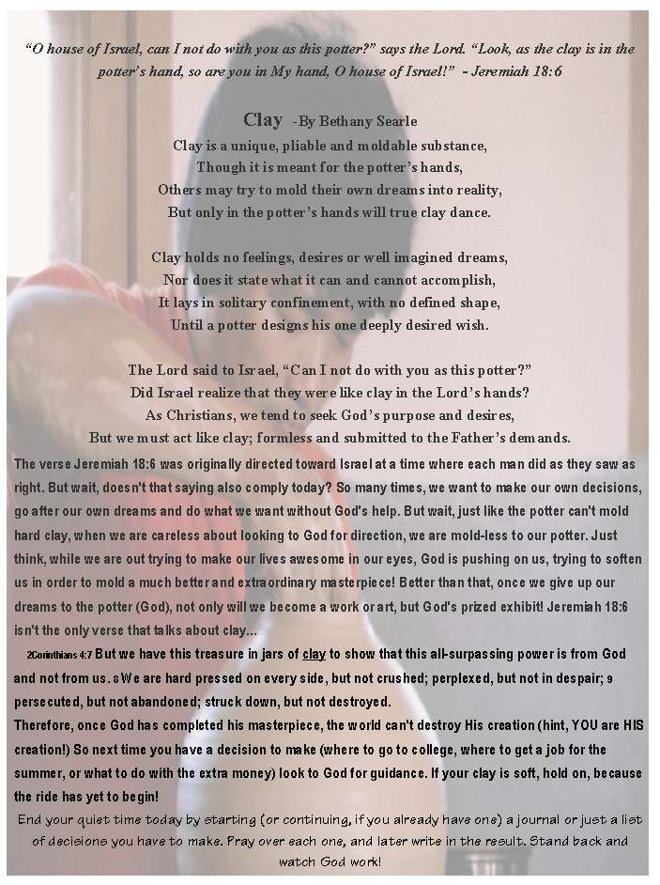

Lesson #7
Title: “The Doctor Is In”

Topic: Jesus As The Wonderful Counselor
Unit Purpose: Discovering “who” really is Jesus
Aim: At the end of this lesson, each student will be able to see Jesus as a source of answers to their problems and start a journal (track record) of ways God has helped them in their walk.

Materials For The Lesson:
- Index Cards
- Bibles (extras for those who might not have one or forgot theirs at home)
- Notebooks
- Poem (see the end of this lesson)

Room Set-Up
Follow the set up from the “Measure It Up” lesson.

Usage Record
Date: Location: Age Group/Occasion

HOOK (15 minutes)
Game- Taken from “Who’s Line Is It Anyway.” Ask for three to four volunteers from the audience followed by one “guesser.” The object of the game is to guess what the other people are doing or are imitating. The guesser runs outside for a moment, while the other three people stay and receive ideas from the audience of what they could do (imitate). The trick of the game is the fact that the actors cannot speak, but the guesser can guess to what the people are doing. The guesser returns and one by one, the actors come in to see the doctor, acting in silence to what role the have been assigned. Once the “guesser” has identified them they are finished and take their seat. Good examples of roles are: “Steve Urcle taking out the trash,” “Lucy,” “imitate your youth minister” or “making an omelet.”
At the end of the game, ask the question, “Have you ever had trouble with something and had nobody that you really thought could understand your situation?”

BOOK (15 – 20 minutes)
Point out the following verse to the group:
(Isa 9:6 NIV) For to us a child is born, to us a son is given, and the government will be on his shoulders. And he will be called Wonderful Counselor, Mighty God, Everlasting Father, Prince of Peace.

Ask the question, “What makes Jesus a “Wonderful Counselor?” Point out the story about the women at the well (John 4:1-26). Jesus reaches out to an outcasted Samaritan woman, declares her issues (an adulterous lifestyle) and offers her the “living water” (which is life in Him). What other stories are there? (Hint, direct the students to the books of John and Matthew, they are filled with encounters that Jesus has with others). Divide the class into groups and make each group act out the passage that they find that illustrates Jesus’ role as counselor. After they act out the story for the class, come up with some common traits that Jesus shows when He cares for others (examples would be witnessing to the outcasted, caring for the disobedient, loving everyone, etc).
End with asking the students, “Okay, if Jesus has all of these traits and is the best one for us to go to when our lives seem to get out of control, why don’t we go to the “Great Physician?” When was your last doctor’s appointment?”

LOOK: (5 minutes)
Give each student a notebook and ask each to write his or her name at the top. Tell them to turn to the first page, date the top, and write a short letter to God, just spilling out what is going on in their lives. If they hate writing, tell them that they can draw a picture of the situation or even just make a note that they are giving the issue over to God. The notebooks stay with the students or they can be left and continued each Sunday as a part of class keeping a record of how God is working in their life.

TOOK: (10-15 minutes)
Give a copy of the following poem to each student to keep. It’s a reminder of just going to God when things are going well and when life literally bottoms out. No matter what the circumstance, God is right there, twenty-four hours a day.

Bethany Searle – 1/20/2002

On Demand
The Gold Pass lies in your hands,
Unlimited access on demand,
Always a voice listening on the other end,
Open early, late; never closed for the weekends.

As troubles arise, this service never fails to respond,
Though patience you must learn, answers will call at the dawn,
A crying shoulder, a coach, a trophy case,
You must follow, can you keep up the pace?

A telephone is not required, most prefer their knees,
No one eight hundred numbers, but trusting for relief,
Prayer is an honor, for you have the direct connection,
Kneeling before the throne of the Father, in humble admiration.

His guidance is the light in the darkest life storms,
The words He speaks has the ability to transform,
Busy signals in His gates do not exist,
If you ask for advice, He will never resist.

The question still lies in your hands,
Will use this service on demand?
Free, filling, peaceful and powerful,
Stronger than the advice of man, go on demand to the Creator for counsel.



Lesson #8
Title: What Are You Looking At?
Topic: Spiritual blindness
Unit Purpose: Discovering “who” really is Jesus
Aim: At the end of the lesson, each student should be able to find an area in which they need to learn to look through God’s eyes and carry the blindfold throughout the week as a reminder.

Materials For The Lesson:
- A large field or if bad weather a large open gymnasium
- Strong rope (climbing rope is usually the best)
    - Ropes need to vary in size, length and texture
    - There must be enough rope to attach to trees (or objects) to make a traveling environment.
- Water guns
- Blindfolds
- Something to give the students after completion of the course (drinks, snacks)
- Video Camera (optional, but a good tool)
- Marker

Room Set-Up
The room or outdoors area in which the students are residing needs to be open, lively and just a fellowship type of atmosphere. No chairs are needed and no food should be provided (this will be served after the game).

Usage Record
Date: Location: Age Group/Occasion

HOOK (time depends on weather and the size of the group)
BEFORE the session, the ropes need to be tied around various objects (preferably outside). The course should begin with one rope and then fork off in various directions. One designation is straight and leads directly to the end (or heaven). The other destinations may either eventually lead back to the straight path or lead to dead ends or confusing destinations. All of the members are blindfolded and told one simple direction, “Do not let go of the rope.” Several people (usually sponsors) will have squirt guns trying to get the members of the class to avoid completing the route to heaven. Other sponsors may entice the group by trying to bribe members off the rope and leading them to the middle of nowhere. Once the members have left the rope, they are told to sit down and keep the blindfold on tight. Any person who removes the blindfold is taken out of the game. One faculty member videotapes the entire experience, which can be viewed by the entire group at a later time. After all the members have left the rope (either by making it to heaven or leaving the rope) the game is over. The group should meet as a whole and the sentences are given. The students that left the rope before making it to heaven were in “hell.” The students who made it to the end were in “heaven.” Ask the group what they thought about the experience followed by showing the video.

BOOK (15 – 20 minutes)
Begin with posing the question, “How many would like to wear their blindfold for the rest of their entire life? Likely, there will be one or two hands. If so, the best way to handle this is to literally blindfold the two for the remainder of class. They may later become illustrations to the story shared.
Find one person to read John 9 or have the assembly form groups sharing the chapter together. With the group gathered once again as a whole, discuss the outline of this chapter. A man that was blind from birth and therefore immediately seen as trapped by sin is healed by the touch of Jesus. But wait, go to the end of the chapter and read the following:
(John 9:35 - 41 NIV) Jesus heard that they had thrown him out, and when he found him, he said, "Do you believe in the Son of Man?" "Who is he, sir?" the man asked. "Tell me so that I may believe in him." Jesus said, "You have now seen him; in fact, he is the one speaking with you." Then the man said, "Lord, I believe," and he worshiped him. Jesus said, "For judgment I have come into this world, so that the blind will see and those who see will become blind." Some Pharisees who were with him heard him say this and asked, "What? Are we blind too?" Jesus said, "If you were blind, you would not be guilty of sin; but now that you claim you can see, your guilt remains.
Before we are Christians, we begin our life blind from everything that God wants and desires to show us (spiritually). However, once we accept Christ as our Savior and guide, our eyes ultimately are opened to the wonders Jesus has surrounded our life around. However, just like the rope, we cannot see our future and we are blind about what lies ahead. You had absolutely no clue how far off course you were while hanging desperately onto the rope. Just like this, we cannot always “see” what God is doing in our life, but we spiritually “see” God working through our actions and activities. A true Christian remembers life in darkness but walks with their eyes half open. The man in the story had both his spiritual and physical sight opened. However, upon persecution he stood true to what he knew and spiritually saw as truth.
(John 9:29-33 NIV) We know that God spoke to Moses, but as for this fellow, we don't even know where he comes from." The man answered, "Now that is remarkable! You don't know where he comes from, yet he opened my eyes. We know that God does not listen to sinners. He listens to the godly man who does his will. Nobody has ever heard of opening the eyes of a man born blind. If this man were not from God, he could do nothing."
Look at this firm stand! He understands that through Jesus only could his sight have been healed. He also testifies boldly that Jesus is from God. Imagine what would have resulted if Jesus had decided not to heal this man on this day. His physical blindness along with his spiritual darkness would still be in place. Where are you? What are you looking at? Do you see darkness, light or half and half?

LOOK: (5-10 minutes)
All of us can relate to the blind man, whether we want to admit it or not. The question is what are you seeing now?
A portion of the “Matrix” can be shown to illustrate the point that once we step out of the world’s blindness, we can see the truth, but not the future. In the Matrix, the man that “follows the rabbit” has a choice. He can venture inside the Matrix and discover the truth or he can stay knowing what he does at that current time. We have the same choice. But look at the ending results. If we choose to follow the world, our sight is going to be the same as everyone’s. We will not see the trap we are in, nor will we find a way out too easily. If you know a non-Christian who is totally against entering a church building, you may relate well with this situation. The main impact is, however, that Jesus sees us in this darkness and He is standing by our side with the mud in hand that can give us sight. Here is where the personal choices come to play.
Choose your own adventure. Will you wash the mud off of your eyes and discover the truth and the world through God’s eyes or will you depend on your own decisions. This world is dark and we need light. The question is, will you be able to see the light? Can you be the light?

TOOK: (10-15 minutes)
Give each student a marker and tell him or her to draw a figure or symbol that represents an area in his or her life in which they are not looking through God’s eyes on a daily basis. Some examples are: not trusting God with their future, stressful home life, stressful work or college lifestyle, big decisions that are being made, or even judging others according to their own standards. The leader should complete their blindfold before the session begins. Also have each student and sponsor write “John 9” on the blindfold in bold letters. The task for the rest of the week is to use the blindfold as a reminder to pray that God can open the eyes of each student (not just themselves) in the area listed. Some helpful reminder places would be to carry the blindfold around in their pocket, purse, car, in their bed, by the pillow, near the alarm clock or even in the bathroom. God doesn’t care what time we pray, as long as we pray in the right manner.



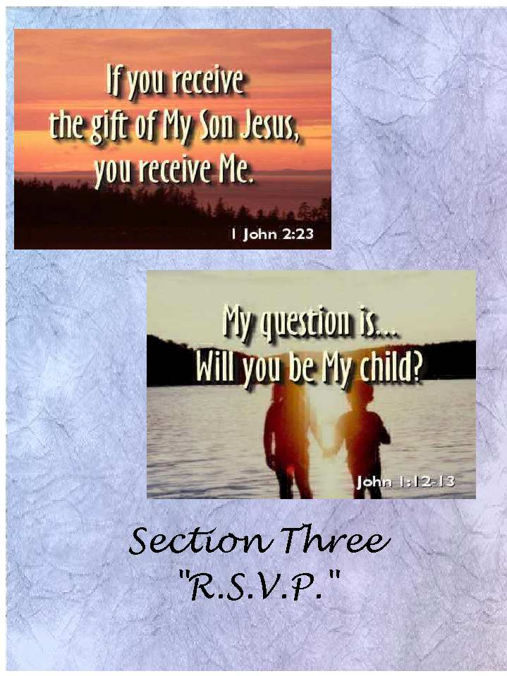

Lesson #9
Title: “Feed The Need”
Topic: Recognize The Need
Unit Purpose: Responding To The Invitation
Aim: At the end of this lesson, each student will be able to recognize the “spiritual” food in their life and their need for Christ’s abundant supply.

Materials For The Lesson:
- “Breakfast bar” (Anything and everything that a teenage student would crave – doughnuts and fruit are a must).
- Paper plates, napkins, forks, spoons, cups, etc.
- A table (s) to hold the food
- Post cards (sent the week BEFORE the lesson).
- Note cards

Room Set-Up
Follow the set up from the “Measure It Up” lesson. Hide the “Breakfast bar” until all of the students are seated and after the explanation of whom the bar is for.

Usage Record
Date: Location: Age Group/Occasion

HOOK (15 minutes)
A week before the lesson, send out a postcard to the class telling them that this week, breakfast will be served at church. This could also include, “Come hungry and be filled…we will feed the need.”
Divide the class into fourths (either by tables already set up or by groups and then led to their tables). Three out of the four tables already have a plate, napkin, fork, spoon, and cup of orange juice (anything will do) sitting at the table. The last table is bare with nothing on the surface. Make an announcement that the first three tables cannot move from their seats. The last table is then released to the breakfast bar that is just then brought to the student’s attention. The goal of the experience is to wait for someone from the breakfast bar to bring food to another at the table (basically, having someone willing to get food for another person with the inability to move). If after ten minutes the one table has not received the idea on their own, start by filling up a plate and sitting it in front of a person at one of the three minor tables. Likely, the fourth table will join in and assist you.

BOOK (15 – 20 minutes)
Recount the experience of the class. Ask the students what the point was of the breakfast that they have eventually received. Ask the tables who had nothing to eat to share with the one table that had plenty how it felt to see them receive food (lost, confused, hungry). Make the point to the entire class that before they entered this door, they were hungry. Now, by some means, they have been filled. We all need food, but how we get fed is up to us.
The scripture reference for the lesson comes from Mark 6:33-44 (Jesus feeds the five thousand). The class can read the scripture passage together in the group. The points that need to be addressed are:
- Jesus felt compassion on the people. The people were seeking for a shepherd.
- What comes first here? The food or the people? (The people had to come to Jesus in order to receive the food).
- Who is the real hero of this story?
      - Jesus?
      - The disciples? “You feed them…”
      - The boy ((John 6:8-9 NIV) Another of his disciples, Andrew, Simon Peter's brother, spoke up, "Here is a boy with five small barley loaves and two small fish, but how far will they go among so many?"
These questions can either be asked out loud or completed and answered as groups.

LOOK: (5 minutes)
Are you hungry for spiritual food? Do you have questions that need answers that nobody can give you? Why are you here on this earth? What is God’s plan for your life? We all need spiritual food.
There are two categories in the story and we as followers of God fit into one of these:
- The boy – You understand where God is leading you and you know how important you are to Him. You are sitting at the table that has the ability to bring food to others. You have the spiritual knowledge to save lost souls through Jesus Christ. A small portion of food (five loaves and three fish) fed five thousand men, not including women and children! Are you using the knowledge and spiritual food that you have to witness to others?
- The disciples – Yea, you definitely know who Jesus is and you try your best to follow Him. But do you really have enough knowledge to witness effectively to others? How far can a little bit of spiritual knowledge really go? Can you trust Jesus and accept the food He is offering you? Can you share it with others?
- The crowd – You may be asking, “Who is this guy who provides free food? You see others around you who seem to be so excited about following Christ, but you really don’t understand what it all means. The bread is coming your way; will you accept the food Jesus is offering you? Can you trust the Bible? Do you want to know more? If so, you are hungry for God, the spiritual food.
Where are you? Everyone fits in the picture somewhere.
To make this part of the lesson come to life, have each part of the lesson (the boy, the disciple, and one person from the crowd) state their concerns to the students. Almost like a debate, each character will have a different view of what happened and the youth can even choose a character to become.

TOOK: (10-15 minutes)
Pass out a sheet of paper with the three positions stated. Ask each student to circle which one best describes him or her and to include their e-mail or address with their sheet of paper. Collect all of the papers and respond to each one accordingly in the next week. For the ones who circled the boy – invite them to form an outreach team, possibly even help lead the “Eggs-Vangelizm” lesson. All of the one’s who labeled the disciples are right in the middle, encourage each of these students to really dig into the Word and build up a passion for leadership. Invite them to invite others to the last lesson of the series. Stretch them for reaching others. They need your support. The last group may be the hardest, for they are the “seekers” or the crowd. They may be visitors to the church or long-term members. They may be non-Christians or baptized believers. Add them to your prayer list and just encourage them to return next week. They are more likely to ask you questions in the future, which you may want to be prepared to answer. They are trying to define their faith.



Lesson #10
Title: “Not Another Excuse”
Topic: Saying You’re Sorry (Spending Time With Your Father)
Unit Purpose: Responding To The Invitation
Aim: At the end of this lesson, each student will be able to recognize their need for forgiveness and seek God’s forgiveness in their life as well as forgive one person this week.

Materials For The Lesson:
- Props for drama (optional)
- Michael W. Smith’s “Friends” song
- DC Talk’s “Between You And Me”
- Two large sheets of brown paper
- Pencils
- Paper

Room Set-Up
Follow the set up from the “Measure It Up” lesson.

Usage Record
Date: Location: Age Group/Occasion

HOOK (15 minutes)
Drama- Two guys from the youth group are on stage, silently shaking hands and greeting each other. However, once in a while, their pleasant atmosphere of friendship is suddenly stopped. For instance, a beautiful girl may walk by the two and one deci9des to try to beat the other to get to her. The two guys break into a fight and the girl shakes her head and walks away. The two eventually resolve themselves, shake, and continue to talk. Then one guy decides to throw a football to the other and ends up hitting him on accident. The result is another fight followed by a make up handshake. The skit it done with the song, “Friends” in the background which makes this a humorous tone. The stimuli used to start a fight can be as humorous as possible. Creativity is needed.
Eventually the song fades and one of the guys is left on stage (or possibly a fresh new character addresses the crowd). He pretends to pick up the phone and is arguing with a person on the other end (pretend). The monologue should be close to the following:
(Talking on the phone) Yea, that kinda party sounds great. Are her parents out of town? Yea, I never tell my parents where I go, well, at least I don’t tell them everything they need to know. Hey, this is my life, might as well live it our, right? (Pauses) … So that’s eight o’clock at her house, but I’ll tell my parents I’ll just be spending the night with you. (Pauses again)… Oh, I can’t do that; I need to be in church Sunday morning. (Pauses)…Okay, I’ll see you then. Later.
(Puts the phone up and another guy comes on stage) The two greet and guy #2 mentions that he hasn’t caught up with his friend for a while. He mentions that he is always waiting on his friend to just stop by and say hi. The other guy responds saying he has way too many problems to deal with to be hanging with his friend all the time. Plus he adds that his friend embarrasses him. He always wants to do the opposite, the things that are never cool to do. Guy #2 asks if they can spend some time together, just hanging out for the night. The other guy informs that he has a party to go to and he can’t drag him along. He even states that his friend will not be welcomed there. The two argue, and eventually guy #1 presses guy #2 to a wall. Guy #1 lifts the arms of guy #2 and sticks them in place (guy #2 is in the position like Jesus would be while on the cross). Guy #1 shouts, “There, now stay. I’ll come back for you on Sunday, okay? Thought you wouldn’t mind.” As guy #1 walks off the stage, guy #2 bows his head and the play ends.

BOOK (15 – 20 minutes)
Begin by asking the group who guy #2 was in the skit (Jesus) and ask why these two scenes were done back to back. After getting response, advance to the Biblical passages. Give each group a scripture and ask them to read them aloud to the rest of the class.
(Mat 28:19-20 NIV) Therefore go and make disciples of all nations, baptizing them in the name of the Father and of the Son and of the Holy Spirit, and teaching them to obey everything I have commanded you. And surely I am with you always, to the very end of the age."
(Rev 3:16 NIV) So, because you are lukewarm--neither hot nor cold--I am about to spit you out of my mouth.
(Josh 1:5 NIV) No one will be able to stand up against you all the days of your life. As I was with Moses, so I will be with you; I will never leave you nor forsake you.
(Luke 17:4 NIV) If he sins against you seven times in a day, and seven times comes back to you and says, 'I repent,' forgive him."

The following points should hit home from these passages (one from each passage):
- He is with us always, therefore, He sees everything and gives us the power to do anything through Him.
- We cannot “act” like we are following Christ. Either we are for Him or we are against Him. God knows our true hearts.
- God does not leave or forsake us. We forsake and leave Him. But, with God by our side, we have the ability to forgive others.
- God tells us to forgive others, no matter how many times. God forgives us countless times. Forgiving another is the least we can do to be Christ-like in mind.
Many Christians struggle with the last verse. We should forgive those who seek our forgiveness, no matter how many times they ask or how deep the wounds. We do the same with God, yet he forgives us each and every time. When was the last time you came as a child before your heavenly father and said, “I’m sorry?” Isn’t it about time?

LOOK: (5-10 minutes)
With two large, brown sheets of paper, form a cross at the place in the drama where “guy #2” was nailed down. Place a few pens around the cross and ask each student to come forward and write or draw something that they need to ask God’s forgiveness. The DC Talk song can be played during this time.
After each person has identified a place in their own life where they seek God’s forgiveness, ask the students to identify with a first name or a symbol of a person who they need to forgive this week.

TOOK: (10-15 minutes)
Make the point that the students have literally left their sins at the foot of the cross and that God has forgiven them. However, now they must forgive the name that is somewhere on the cross. Thus, the challenge of the week is to verbally or in written form forgive another person that they feel has done them wrong. Pencils and paper should be available for any student that feels led to write a letter at that time.


Lesson #11
Title: “Mouth In Motion”
Topic: Verbalize The Truth
Unit Purpose: Responding To The Invitation
Aim: At the end of this lesson, each student will be able to realize the significance of the words they use in day-to-day conversation and literally witness with words.

Materials For The Lesson:
- “Un-censored” Video
- “Un-censored” Tape/CD
- (Optional) props for skit
- Magazines
- Newspapers
- Poster board
- Glue
- Scissors

Room Set-Up
Follow the set up from the “Measure It Up” lesson.

Usage Record
Date: Location: Age Group/Occasion

HOOK (15 minutes)
A week before the lesson is to be done, record various segments of television programs to a VHS (or if the technology is available, a DVD). More than likely, vulgar language is used periodically throughout the shows or movies caught on tape. Edit the footage so that a few scenes are shown which INCLUDE the vulgar language. A CD or tape of a few of the top secular songs of the week should also be made in the same way. Have both the music and the video going (the music should be background level, but noticeable) as the students arrive.
Also, make a second video, including just the short words that “are usually not tolerated” in a church setting (some churches may vary on this issue). Contrast the video with the “Jesus” movie, or any dramatic interpretations of Jesus’ life. Both parts should flip back and forth throughout the video. Maximum length should be five minutes. The music works the same way. Include at least six blurbs of various secular songs and interrupt Rich Mullins’ “Oh God You Are My God” with the secular music, picking up the song each time, after interrupted, from where it left off.
Example – “Oh God you are my God” – secular blurb interruption…”and I will ever praise you” – secular blurb… (Etc.)
As the youth enter, the original secular video and music are playing. After all the youth arrive, begin the class with showing the edited secular video contrasting with dramatic interpretations of Jesus’ life. The group may be a little uneasy at the end of the video, but insist that the youth have a worship time to lighten the mood. Begin the Rich Mullins song with the interruptions and just let the youth react. Depending on the reaction, you may have one or two students that take over the class by testimony, debate, or discussion. If you receive the comment that you should not be presenting this material, ask the youth, “Why?” This will lead to the “Book” portion of the lesson.

BOOK (15 – 20 minutes)
Ask the group, “Why did our Creator, God, make us with a mouth?” Write these ideas down or just make note of each mention. Then ask, “Why don’t we do this?” Some examples are praising God verses we don’t have time or witnessing verses un-popularity.
Share the following verses with the group:
(Exo 20:7 NIV) "You shall not misuse the name of the LORD your God, for the LORD will not hold anyone guiltless who misuses his name. (If we misuse the name of God, we are putting ourselves higher than God and disgracing His name. It deserves honor and respect.)

(Gen 1:3 NIV) And God said, "Let there be light," and there was light.
(Gen 1:6 NIV) And God said, "Let there be an expanse between the waters to separate water from water."
(Gen 1:9 NIV) And God said, "Let the water under the sky be gathered to one place, and let dry ground appear." And it was so.
(When God speaks, great things happen. When we speak, our words do not bring a tree into existence, but it is still a powerful thing. Our words define who we are.)

(Exo 4:10 NIV) Moses said to the LORD, "O Lord, I have never been eloquent, neither in the past nor since you have spoken to your servant. I am slow of speech and tongue."
(Exo 4:11 NIV) The LORD said to him, "Who gave man his mouth? Who makes him deaf or mute? Who gives him sight or makes him blind? Is it not I, the LORD?
(We all male excuses to why we cannot verbally share our faith, but God can speak through us. Look how He used Moses.)

(Job 15:5 NIV) Your sin prompts your mouth; you adopt the tongue of the crafty.
(If we continue to watch and listen to the language of the world, then our language will be the same. When a baby is born, it doesn’t automatically speak on it’s own. However, after paying close attention to the words being used around them, they eventually learn the language and meanings within years. Once we learn a habit, it will be hard to break its hold.)

(Phil 4:8 NIV) Finally, brothers, whatever is true, whatever is noble, whatever is right, whatever is pure, whatever is lovely, whatever is admirable--if anything is excellent or praiseworthy--think about such things.
(If we look to these things, then we will begin to see joy and peace in life. Does someone who complains about everything ever bog you down? Words affect us both positively and negatively. Telling someone that they are loved and created by someone who truly cares for their life might be the only words of truth they hear that day, week, month, etc.)

LOOK: (15 minutes)
Words are definitely a part of your life. Get a few magazines together and ask the class of form groups and make a poster by cutting out words in the newspapers and magazines that they hear on a daily basis. They have to be words already formed, and no vulgar words should be used. Ask each group to find a verse reference to put at the bottom of the poster and share the finished product with the rest of the class.

TOOK: (10-15 minutes)
Pre-arrange permission to hang the posters up various places around town. Do not put the student’s names on the posters but do put the church address and phone number. It may also be a good idea to put your name and the name of the youth group on the poster as well. Make sure to point out that the group has made a witness out of words (literally).
The poem, “Witness With Words,” can be used as a midweek mailing or can be added into the Book section of the lesson.

1/10/2002 – Bethany Searle

Witness With Words
With few words, God brought the universe into existence,
Through His lips came the Ten Commandments in which to be followed,
God spoke to Elijah in the wind, through just a gentle whisper,
The tongue is powerful, but one word from God can leave human conversation as shallow.

With the words, “follow me,” Jesus found his first dedicated disciples,
Through Jesus’ lips a blind man received sight, Lazarus rose with life,
Jesus’ parables and teachings were all through prized speech,
It was with compassion that Jesus forgave his murders, with the words, “It is finished,” his death became a powerful sight.

The tongue can hurt, heal, cut and sew,
God gave us the gift of speech for a unique and praiseworthy purpose,
What do your daily words speak about your all-knowing Creator?
Following Christ’s example all humanity must hear, each syllable rings through God’s ear, it scratches much deeper than the earthly surface.


Lesson #12
Title: “Chillin’ On The Mat”
Topic: Plunge The Past
Unit Purpose: Responding To The Invitation
Aim: At the end of this lesson, students will be able to see how Christ can heal their past and consider the fact that all humanity is God’s masterpiece.

Materials For The Lesson:
-Box
-Marker
-Poem

Room Set-Up
Follow the set up from the “Measure It Up” lesson.

Usage Record
Date: Location: Age Group/Occasion

HOOK: (10-15 minutes) Silent Drama- The scene opens with two people on stage and a box labeled with various words (sin, depression, drugs, sex, anger, hatred, anxiety…more can be added). The two actors on stage pretend to have a conversation with each other, moving closer and closer to the box, which lies in the middle of the stage. They both stop to look at the box and begin to question each other. One waves to the other and walks away, but watches from a distance. The actor standing close to the box slowly and experimentally puts his or her foot into the box. Surprised that nothing happened (or so it seems) they bring the other foot into the box as well. At this point the actor may sit down, pretend to drink a soda and get comfortable while crouching inside the box. The other friend comes along and notices his friend’s behavior and motions for him to follow. However, the actor in the box is at first reluctant to leave his living quarters, but eventually stands up and realizes that his feet are stuck within the box. First, the actor tries to escape by himself, pushing and pulling; even dragging the box with his feet across the stage. Second, his friend tries by pulling, pushing and even flipping the box to break his friend loose. However, all fails and the actor is still miserably stuck inside the box. The other friend pulls out a Bible that he has hidden originally from the audience. He reads John 8:32 to the audience (not facing his friend which listens from inside the box).
(John 8:32 NIV) Then you will know the truth, and the truth will set you free."

After he reads the verse, he shrugs towards his now frustrated friend and walks off stage. The friend still stuck in the box, says in anger to the audience, “Truth? What truth?” Immediately the lights dim and the drama ends.

BOOK: (15 minutes) The main speaker now takes his or her place on stage and the box still sits towards the front of the area. The “sermon” or “lesson” begins initially at this point.
Have you ever felt stuck in a box quite like one of the actors on stage? Maybe you fell into it by accident or possibly you may have gotten pushed in, but all of can relate to being stuck at one time in our lives. How do we get out? How do we help others out?
In the gospel of John, Jesus finds a man in a stuck situation. (At this point, the speaker can choose someone to read this scripture passage, or they can read it themselves. familiarization is the key.)
(John 5:1- 5:9 NIV) Some time later, Jesus went up to Jerusalem for a feast of the Jews. Now there is in Jerusalem near the Sheep Gate a pool, which in Aramaic is called Bethesda and which is surrounded by five covered colonnades. Here a great number of disabled people used to lie--the blind, the lame, the paralyzed. One who was there had been an invalid for thirty-eight years. When Jesus saw him lying there and learned that he had been in this condition for a long time, he asked him, "Do you want to get well?" "Sir," the invalid replied, "I have no one to help me into the pool when the water is stirred. While I am trying to get in, someone else goes down ahead of me." Then Jesus said to him, "Get up! Pick up your mat and walk." At once the man was cured; he picked up his mat and walked.
Okay, so you are thinking, “What is the deal with this pool?” The pool, Bethesda, which in Aramaic stands for “House of mercy” was a place for the crippled and lame to gather in hope that they might be healed. “From time to time an angel of the Lord would come down and stir up the waters. The first one into the pool after each such disturbance would be cured of whatever disease he had.” It was hope of being cured that kept several people around the water day to day.
So, Jesus ends up walking by and sees this man lying on a mat, weak, depressed and possibly even gazing into the water hoping that his luck was running today. However, all of the sudden Jesus, a person that this man evidently has no knowledge of his presence (he called him sir, not Messiah, Lord, etc.), asks him, “Do you want to get well?” What would your reaction be? Here you have trusted this water for healing and someone actually asks you a question like this? The man replies that he wants to get well, but he is not quick enough to get into the water by himself. However, the next statement by Jesus shows that this man will see the truth. Jesus says, “Pick up your mat and walk.” Notice, he did not say, “If you trust me,” or “Hey, put your faith in me,” or even “When I touch your feet you will be healed.” Instead, he just commands the man to stand up and walk! How crazy is that to this world today? What trust that crippled, lame man must have experienced. Have you been there? Are you there now?

LOOK: (10 minutes) A lot of us go through life, finding a nice box or in this case, a mat, to lie on. I know, it might not be our fault that we have fallen, but here you lie. You might be going through a parent’s divorce. You might be having tough situations at school. Possibly your friends have left you high and dry. You know the situation that lies beneath you. However, what do you do now? How are you going to get up?
You say, “I’m sitting near the pool, eventually I will be healed.” Maybe your parents will work things out, or maybe your friends will call and beg for your forgiveness. Do you notice the key phrase here is, “maybe"? When the lame man sat so many years by the pool, I can’t imagine a day that the man would not have thought, “Maybe I will be healed today.” However, the passage says that he had been crippled for thirty-eight years! I don’t know about you, but the mat would begin to ware after so much sitting.
So, let’s see, one day you come face to face with Jesus Christ himself. He asks you (the speaker may reach out their hand at this point) if you would like to be healed. My friend, he is not going to help you into the water, but he will help you leave your mat, get out of the box, and back on your feet. However, the answer is yours. Choose your own adventure…one way leads to possibly thirty more years sitting on the mat trapped by life’s problems, or the other choice could be to leave your problems on the ground and follow his lead. I don’t know about you, but I want to stay close to his shadow.
“Follow (or sit) at a distance and you’ll deny the Master. Period.
You won’t die for a man you can’t touch. Period.
But stay near to him, in his shadow…
You’ll die with him, gladly.”

TOOK: (10-15 minutes) There is two sides two this incident in John. You don’t necessarily have to be on the mat. Maybe your life is going fine, you are following Jesus in his shadow and you can see yourself as the friend with the Bible in the earlier drama. The truth is that Jesus Christ can set anyone free from the mat, no matter the situation. If we can’t trust our Creator, whom else can we trust? So, you know God’s message and you also see people daily sitting on the mat, waiting for something to go right so that their life can go back to normal. Are you willing to sit and watch them struggle? Will you try to get them up by yourself? The friend at the end of the drama walked away, knowing how his friend could be freed, but he failed to tell him. Will you be the one to tell your friends about freedom? Following close to Jesus’ shadow is going where the lame and hurting lie. Will you take that risk?
If you are on the mat, are you getting too comfortable? Are you prepared for a long stay? Picture this. You are beside the pool, looking at your mat filled with garbage that begins to stink. Other people who walk by pay no attention to you and all you want is to get out of the trash. The mat is not a comfortable place to be. If you have fallen by yourself, you cannot get up by yourself. If others pushed you down, it takes more than their hand to lift you back to your feet. Jesus is by your side and he is asking you, right now, “Do you want to get well?’ If your answer is yes, you must leave the entire mat (the parents situation, your hurt, your anger, your depression, drugs, alcohol, a dating relationship, even your friendship with another) on the ground. Trust your life with Jesus Christ. You were not created to live life on the ground, but to walk behind Jesus.

CONCLUSION: The following poem is read, and the session is closed.
1/4/2002 – Bethany Searle

The Artist of the Masterpiece
An artist’s paintbrush glides smoothly across the canvas,
The paint shines like the colors of a sunset,
Color by color, carefully a masterpiece is created,
The contrasts of the painting sing a sweet duet.

The painter takes his time, for good work is priceless,
For both his heart and mind are necessities for this art,
Without his passion, his painting would be blank,
And his tight grasp on the brush would soon part.

But a creator loves his creation with all of his heart,
No mistakes, smudges, or incorrect colors are used,
For each masterpiece is created for a distinct purpose,
Each painting is different, with various futures to pursue.

We are all God’s children, his wonderfully created masterpieces,
Each and every living soul is His own prized joy,
Regardless of race, color, nation or country,
Our Creator gave everyone a life to enjoy.

Next time you see one of God’s own paintings,
Maybe fallen off the wall, cracked and abandoned,
Remember the precious Creator that presented you with the breath of life,
And lift the masterpiece, ever so high, for it belongs in God’s hands.

Final words- this poem is a reminder that everyone here, on the mat or under Jesus’ shadow is loved and cared for equally by their creator. Keep this in mind as you go through your week.

Lesson #13

Title: “Eggs-vangelism”

(This lesson is longer due to the materials and completion of the curriculum).
Topic: Pass it on! (Successful Evangelism and D Day)
Unit Purpose: Responding To The Invitation
Aim: At the end of the lesson, each student should be able to successfully share an egg with at least one other person this week.
* This lesson should be done before, on, or after Easter Sunday for best results.

Materials for the Lesson:
- Plastic Easter Eggs (one for possibly each member of the class). Each egg should contain the following items:
  - Nail (possibly rusted with a sharp tip for effect)
  - Wire (best if bent and twisted into a small circle and might also have a few sharp edges for effect)
  - Piece of a Sponge (a regular sized sponge can be cut to at least 20 pieces if needed)
  - White Cloth with a Blood Stain (an easy way to complete this task is by taking an old pillowcase and tearing it into several small pieces. With a red marker, shade in a smudge of color onto the sheet)
  - Small Rock (the bigger, the better – as long as it can easily fit into the egg)
  - Cotton Ball (white)
  - Verse (a small slip of paper with the verse 1 Peter 1:18-19 typed in red letters and font effects can also be added)
- Note Cards (one for each student, used for feedback and can either be blank or pre-typed with lines for a student’s name, address, telephone number, etc.-see example in the “Took” section)
- Pockets (big enough that one plastic Easter egg can be easily put inside without the class identifying it- a separate hiding place can also be used, as long as the class is not able to find the egg)

Room Set-up:
The room should be big enough for movement by the entire class and for tables to be set up. An approximate number of chairs per table would be around five, including a seat for the group leader. A “coffee house” type atmosphere can also be adapted. Therefore, drinks can be easily accessed, Christian music can be heard in the background (possibly even a live band if teaching a large group), and as the students enter the room they are able to converse with each other. However, for this specific lesson, no food should be accessible at the beginning of the lesson.

Usage Record
Date | Location | Age Group/Occasion
4/10/01 | K.C.C. Dorm Devotion | College (Easter devotion)
4/12/01 | K.C.C. D-Group Devotion | College (Easter devotion)
4/15/01 | Southern Acres Christian Church | Junior High-College (Easter Sunday)
4/16/01 | K.C.C. Speech Class | College (speech to convince)

Hook (15 minutes):
Begin the class by running in franticly and making the announcement that the Easter egg, which was to be used for the lesson is missing and cannot be found. If you do not find the egg, then the lesson will be ruined. For older groups, you can also add in that the egg contains something “priceless” inside and that you were going to share it with them in the lesson. Immediately it seems that teenagers especially think that there is some form of food stashed in the egg that is lost. Since there is no food accessible to them at this time, they are immediately ready to begin the task of searching. Even if only a few react to the task, others will soon join in by their lead. You intensely act as if you are looking for the “missing egg” as well, but you in fact have the egg either hidden in your pocket or stashed away in a known location. Once the group begins to wave the white flag and mumble suggestions that support the idea of quitting the search, immediately make the group take their seats. Once the entire group is seated, slowly pull out the egg from it’s hiding place. Suddenly someone will ask the key question, “Why didn’t you just give us the egg to begin with?” Your reply consists of two main answers. The first, “Why do we keep the true meaning of Easter hidden from other’s view?” The second response is, “How many of you just spent more time and effort looking for a plastic Easter egg than you have telling someone the real meaning of Easter in the past week? Month? Year?” Your audience will be silent and ready to listen.

Book (20 minutes):
A good way to get the class interested in listening to the Bible verses is to show a silent dramatic video of Christ’s crucifixion and death. Another person can control the video, so that the verse that is being read matches what is being acted out on the screen. If possible, practice reading the below passages so that it can be read with both accuracy and meaning.
(John 19:14-20 NIV) It was the day of Preparation of Passover Week, about the sixth hour. "Here is your king," Pilate said to the Jews. But they shouted, "Take him away! Take him away! Crucify him!" "Shall I crucify your king?" Pilate asked. "We have no king but Caesar," the chief priests answered. Finally Pilate handed him over to them to be crucified. So the soldiers took charge of Jesus. Carrying his own cross, he went out to the place of the Skull (which in Aramaic is called Golgotha). Here they crucified him, and with him two others--one on each side and Jesus in the middle. Pilate had a notice prepared and fastened to the cross. It read: JESUS OF NAZARETH, THE KING OF THE JEWS. Many of the Jews read this sign, for the place where Jesus was crucified was near the city, and the sign was written in Aramaic, Latin and Greek.
(It might be necessary to stop at this point and explain how it must have felt to watch this, “King of the Jews” die before your eyes).
(John 19:28-30 NIV) Later, knowing that all was now completed, and so that the Scripture would be fulfilled, Jesus said, "I am thirsty." A jar of wine vinegar was there, so they soaked a sponge in it, put the sponge on a stalk of the hyssop plant, and lifted it to Jesus' lips. When he had received the drink, Jesus said, "It is finished." With that, he bowed his head and gave up his spirit.
(John 19:38-42 NIV) Later, Joseph of Arimathea asked Pilate for the body of Jesus. Now Joseph was a disciple of Jesus, but secretly because he feared the Jews. With Pilate's permission, he came and took the body away. He was accompanied by Nicodemus, the man who earlier had visited Jesus at night. Nicodemus brought a mixture of myrrh and aloes, about seventy-five pounds. Taking Jesus' body, the two of them wrapped it, with the spices, in strips of linen. This was in accordance with Jewish burial customs. At the place where Jesus was crucified, there was a garden, and in the garden a new tomb, in which no one had ever been laid. Because it was the Jewish day of Preparation and since the tomb was nearby, they laid Jesus there. (The last part is often not seen in any dramatic presentations and is never read. Take the time to go slowly and tell the class to put themselves in the apostles’ and Mary’s shoes.)
(John 20:1-16 NIV) Early on the first day of the week, while it was still dark, Mary Magdalene went to the tomb and saw that the stone had been removed from the entrance. So she came running to Simon Peter and the other disciple, the one Jesus loved, and said, "They have taken the Lord out of the tomb, and we don't know where they have put him!" So Peter and the other disciple started for the tomb. Both were running, but the other disciple outran Peter and reached the tomb first. He bent over and looked in at the strips of linen lying there but did not go in. Then Simon Peter, who was behind him, arrived and went into the tomb. He saw the strips of linen lying there, as well as the burial cloth that had been around Jesus' head. The cloth was folded up by itself, separate from the linen. Finally the other disciple, who had reached the tomb first, also went inside. He saw and believed. (They still did not understand from Scripture that Jesus had to rise from the dead.) Then the disciples went back to their homes, but Mary stood outside the tomb crying. As she wept, she bent over to look into the tomb and saw two angels in white, seated where Jesus' body had been, one at the head and the other at the foot. They asked her, "Woman, why are you crying?" "They have taken my Lord away," she said, "and I don't know where they have put him." At this, she turned around and saw Jesus standing there, but she did not realize that it was Jesus. "Woman," he said, "why are you crying? Who is it you are looking for?" Thinking he was the gardener, she said, "Sir, if you have carried him away, tell me where you have put him, and I will get him." Jesus said to her, "Mary." She turned toward him and cried out in Aramaic, "Rabboni!" (which means Teacher).
Group leaders (who have been previously taken through the lesson and are of an older age or are highly respected and admired among the group) are placed at each table with four to five other students. Each group leader also has in their possession one egg with the noted materials inside. Before the leaders begin their part of the lesson, you ask the students “Why did you search so hard for the egg?” Someone will mention the candy that they thought they might find or the comment that you made regarding their being something “priceless” inside (sometimes a student is pre-selected to respond to the question if the group falls silent). Once answers have been given, signal to the group leader’s to open their eggs. Students are either surprised or disappointed to see what contents lie inside the egg. The groups begin their discussion and distribution of materials that are found inside the egg. At this point, you can bring food to the table and leave it in the center for the groups to snack. It has been found that when eggs are given to the group members at this time, their attention is off topic and their hands are too busy playing with the items inside the egg to listen to the group leader. Keep one egg per group so that teamwork is needed to discover the various items that lie inside.
Leader’s can use the following chart for easy access to walk the group through the egg’s contents.
Item | Symbolism
Nail | The sharpness indicates a small amount of pain that can come from just barely forcing the end into your finger. Imagine the pain of a larger and sharper nail being hammered into your wrists.
Wire | This can be seen as the “crown of thorns” pushed into Jesus’ head. If you push hard on the surface of the wire, you may feel a pinch. Jesus felt much more than just a slight pinch going through the skull of his head.
Sponge | When Jesus was up on the cross, dying, He was offered a drink from a sponge at the end of a stick. The drink was wine vinegar and after the sponge reached His lips; He gave up His life for you.
Cloth | Once Jesus was pronounced dead, his bloody body was taken off the cross and wrapped in cloth.
Rock | He was placed behind a stone in a tomb. Guards stood and watched the tomb for three days. This rock resembles the stone that rolled away on the third day when Jesus defeated the impossible… death.
Cotton | When you were little, did you ever make a lamb made out of cotton balls? This piece of cotton resembles Jesus Christ as the pure lamb (white as snow) that was the ultimate sacrifice for our sins.
Verse | (Let a group member read the verse aloud to the group and ask another group member what the verse means. Make sure the group connects the verse and the meaning of the cotton ball together). The verse is “(1 Pet 1:18-19 NIV) For you know that it was not with perishable things such as silver or gold that you were redeemed from the empty way of life handed down to you from your forefathers, but with the precious blood of Christ, a lamb without blemish or defect.” *God was perfect and none of us can even compare to His life on earth. His sacrifice was our gateway to eternal life.

When all the groups complete the excavation of their eggs, mention the fact that all items in the egg and even the egg itself is perishable, but it contains a life saving message that can not be replaced.

Look (15 minutes):
At this point in the lesson, a lecture type of atmosphere will be created. The students may stay in their groups, as long as you remain the center of their attention. The following can be used as an example of what can be used for the lecture (The following would be suitable for college or high school students).
Begin by mentioning that we as humans are perishable from God’s grace if we do not know, accept and do what is commanded of us. By reading the Great Commission to the class, it is known that the mission, whether or not accepted or followed through, is to lead others to Christ.
MT 28:19-20 Therefore go and make disciples of all nations, baptizing them in the name of the Father and of the Son and of the Holy Spirit, 20 and teaching them to obey everything I have commanded you. And surely I am with you always, to the very end of the age."
Mention to the class that they now know, whether or not they knew previously, what this egg (which should be in your hand and shown to the group) contains. This plastic egg, however, is a symbol of the knowledge that you now have about Jesus Christ. Are you going to hide it and keep it all to yourself or use the knowledge that you have gained to save your friends from perishing in hell? This is your mission, if you choose to accept it. This egg meant something of worth to you even before you knew exactly what laid inside. Why did you search so hard for a little, worthless plastic egg? Because you accepted the fact that I needed help finding something that was crucial to my lesson and my life. Just like this, your lost friends do not know exactly what lies in this egg that you want them to find. However, if you believe in the death and resurrection of Jesus Christ and if you accept the fact that He died to give you everlasting life, you can literally give them the “egg” that will lead them into eternal life.
All of you who are here today now have the knowledge to save a lost soul. However, do you believe in what you know about Jesus Christ is real? Is there something keeping you from believing one hundred percent, hands down that Jesus Christ bled and died for your sins? Whatever the problem or confusion I promise you there is an answer. Maybe you have the knowledge and have accepted it as true and part of your life. Well, what are you doing about it? If I had not decided to show you the egg, would everyone still be here right now? Would you still be searching or would you have given up? That’s the position of your friends right now, looking and hunting for meaning of their life. Will you give them the answer they need or watch them give up? Will you be the one to congratulate them into heaven or just leave them to suffer in hell?
Another way of visually getting the message across is by holding up the egg (closed) and stating, “This is your brain.” Pop open the egg and let the contents fall into your open hand. Then state, “This is your knowledge about Jesus Christ and salvation…the only thing that can save your friends is in your head, right now.” Put the contents back inside the egg and close the plastic shell. Hold the egg up again and state, “Are you going to keep this life saving information hidden?” Place the egg in the hiding place that was used earlier. Wait a few seconds and take the egg back out and ask, “Or are you going to try to save a life.” After this line, you can toss the egg to a leader, who can pass it to another leader, and so on down through a line of about four to five people. After doing this activity, it is wise to mention the “Took” assignment of taking an egg home and sharing it with another person, giving their friend a chance to share it with another person (illustrated by the line).

Took (20 minutes):
Pass out a note-card to each person (even the group leaders) and ask them to first write down their name and two sources of contact information. The two sources can be a combination of a home phone number, work phone number, cell phone number, home address, college address, e-mail address, or voice-mail. Most commonly asked for is one of each type (one phone number and one address). You might have already recorded this information on file, but it would be good to have visitor information as well. Mention that they have a few options to choose from and they can indicate (or check off) the option that they agree to complete on the card. An example of how a card might look is pictured below.
Name:
Address:
Home Phone: Work Phone: Cell Phone:

Please circle one:
Middle School High School College Group Leader

If in college, please list an extra college based address or phone number that can be used to contact you:

Options- Check ALL that apply:
__ I am taking an egg with me and will share it’s meaning with at lease one other person this week and will encourage them to do the same (the info that you have provided will be used to hook you up with an accountability partner).
__I’m lost! I understand this Jesus thing, but what does it have to do with me? I’d like more information on how I can become a Christian.
Please contact me by (circle one) phone address
__I’ve messed up and I’d like to re-commit my life to the Lord. Please contact me by (circle one) phone address
__I’m not a member of this group, but I’d like more info on upcoming events (sent by mail and e-mail).

PLEASE PUT ALL CARDS IN THE BOX BY THE DOOR ON YOUR WAY OUT!
Have an AWESOME week!!
Note that one of the four choices is the option for the student to take an egg and share it’s contents with at least one person during the week. The “AIM” of this lesson was to get at least one half of all the students to participate in this choice. Mention this option specifically to the class. Include how you went through the egg and even let them practice amongst themselves presenting the egg to each other. You may place a box lying by the door filled with eggs that students can pick up when they walk out, or you can simply hand the eggs out to the students when distributing the cards. If you follow the latter choice, the box can work as a dumping place for the eggs that student’s are not comfortable with sharing. It has been a known fact, however, that more students may keep the egg if handed out with the cards. Remind the class that two forms of communication identified need to be accurate and correct for good accountability placements (you will be putting students together later on in the week for accountability partners and will call or mail a list out to all that checked the first choice). Make sure to have an open box that is easy to access and will not be jammed with cards. Students can simply throw their card into the box on their way out (it might be easy just to point to the box while the group is filling out the card).
Before the group is released, have a group prayer for all of those who have decided to take an egg with them this week. Pray that they will have the courage to share its contents with at least one person and encourage their accountability partner as well. It might be more beneficial to have a student lead the prayer if desired.
The cards should be looked over later to see if the number of eggs actually missing from the box and the number of checked boxes are equal. Some students might have an egg and just forgot to check a box, or maybe the opposite as well. Never the less, it is still necessary to get a number of the eggs actually taken, due to the possible impact that they could have on the group. Also, respond to the last three choices first, and then follow up the lesson. At least wait three days before sending out a sheet of accountability partners (depending on the mail system) or making contacts about the accountability partners. Give the group time to react to the lesson on their own time and turf. Pray for each egg that is missing from the box and it might be reasonable to keep the extras for the following week as an option for other’s to take an egg (or for those who successfully completed the assignment, to reach out to another person the following week). A follow up lesson that consists of testimonies, stories, invitations to all participants, and the tracking down of the eggs should be conducted within a few weeks. If the lesson is given before Easter Sunday, then it can be done at this time. Easter shouldn’t be celebrated just once a year. There is a message in this holiday that needs to be heard regardless the time of the year. Therefore, this lesson can be done even after Easter or more than a month before the celebration.
Each time that I have done this lesson, I have been able to sit back and watch God work in my like and impact others. It is an incredible feeling to know that a plastic egg, filled with perishable materials can save a chain of lives. God can work through anyone who allows Him to lead the way.


Excerpt taken from the NIV Bible Commentary software program
Johnson, Barton W. “Commentary on John 11.” People’s New Testament. 1891 21 Oct. 2000 http:// bible.crosswalk.com/commentaries/PeoplesNewTestament/
Scriptures were taken from the NIV Study Bible Complete Library program (NIV version).
Taken from the book, “Practical New Testament Outlines,” written by Donald A. Nash. (1982)
Taken from the NIV Bible Commentary (software program).
Quote taken from the last section of chapter three in Max Lucado’s “On The Anvil.” Parenthesis statement added by me.
The poem was taken from the "Walk On Water Ministry: A Testimony Of A Writer's Heart" website by Bethany Searle http://members.tripod.com/jfbeth

